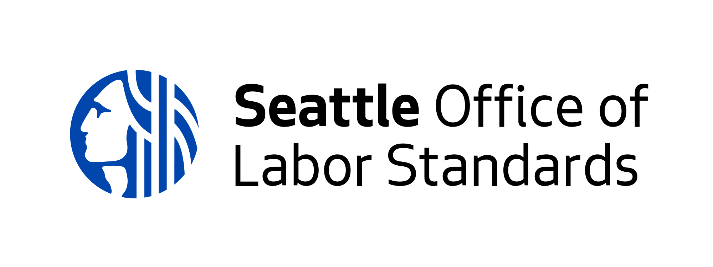

Part 1. We are looking to understand your organization’s experience and skills conducting outreach and education work with low-wage workers.

- Describe methods your organization or collaborative uses to successfully engage and educate low-wage workers on important technical information.
  - This could include outreach on labor standards, housing rights, immigration, social services, etc.
- What does your organization do well to successfully engage and educate low-wage workers?
  - This could include counseling on labor, immigration, or housing rights; securing social services; etc.

Part 2. We are looking to understand your perspective on low-wage worker populations, the problems you see and the strategies you think will bring solutions

- What do you see as challenges to workers in the communities you serve? What approaches do you see as necessary to addressing those challenges?

- What goals or changes do you hope to achieve in worker communities after two years of engaging and supporting workers through this Fund? How does your workplan support this vision?

- What industries in Seattle do you have experience working with? What do these industries do well for workers and what could be strengthened or changed to make workers’ lives better?

- Intakes occur when workers seek you or your organization for guidance about workplace rights, this can occur in person, over the phone, on email or social media. How is your organization or collaborative set up to support workers and conduct intakes?

OLS defines community intakes in four categories, please choose at least one to answer this question.

  - Information Only Intakes: Listening to workers’ complaint and offering guidance on ways to address this complaint, but worker chooses to not take action.
  - OLS Referral Intake: Supporting a worker to file a complaint with OLS and working with them through the process.
  - Organization Resolution Intake: Supporting a worker to file or resolve a complaint without help from OLS.
  - Referral Intake: Supporting a worker to file a complaint with another organization or agency that is a better fit for their needs.

- If you are applying as a collaborative, please explain why you want to work together as a group and what are your points of unity? (ie all organizations serve workers in low income housing) What structures exist or will you set up to be accountable to each other in this work? (ie all organizations will meet monthly to discuss challenges and successes)

- If your organization received funding from OLS through the Community Outreach and Education Fund between 2017-2019: Describe key lessons learned from successes and challenges this past year and how your previous work will inform your strategy for this proposal.

Part 3. We are looking to understand your long-term vision for doing this work with OLS.

- What kind of relationship is needed with OLS to have a meaningful impact in your community?

- What possible challenges do you foresee collaborating with OLS? What strategies or practices will mitigate these challenges?

- How will OLS funding and partnership build capacity for your organization or collaborative to do this work? What commitments do you have to sustain this work long term?

Optional Question: Is there anything else you would like to share with us that these questions did not cover and will help us understand your organization or collaborative better?

